**Hardware Design Document**

**Project:** ECSE211 Design Project – Capture the Flag

**Task:** Construct an autonomous robot that can play one-on-one version of the game Capture the Flag

**Document Version Number:** Version 1.7

**Date:** Nov, 28 2017

**Author:** Priscilla

**Edit History:**

- Created: 23/10/17

|  |  |  |  |
| --- | --- | --- | --- |
| **Date** | **Edited By:** | **Section** | **Reason** |
| Oct. 23, 2017 | Paarth | Requirements | Filled in design requirements |
| Oct. 24, 2017 | Ismail | Proposed design | Added images of hardware design |
| Oct. 25, 2017 | Ismail | Proposed design | Added design information, pros and cons |
| Nov. 01, 2017 | Paarth | Adopted Design, proposed designs | Added info to adopted design and sketches for proposed designs |
| Nov. 2, 2017 | Priscilla | Adopted Design | Renamed Design 1.0 to Version 1.0 |
| Nov. 10, 2017 | Ismail | Adopted Design  4.2 Version 1.1 | Designed and added Version 1.1, justification and features |
| Nov. 14, 2017 | Paarth | 4.2 Adopted Design  4.2 Version 1.1 | Reviewed Version 1.1 and added justification for hardware update |
| Nov. 14, 2017 | Priscilla | All; Version 1.1 | Formatting to reduce white space |
| Nov. 22, 2017 | Ismail | Version 1.2 | Added Version 1.2 new design, features and justification |
| Nov. 25, 2017 | Priscilla | Format;Versions 1.0, 1.1 and 1.2 | Updated to current format; Added main components used and explicitly stated changes |
| Nov. 28, 2017 | Priscilla | Table of Contents | Added links |

1. **Table Of Contents**

2.0 Design Requirements……...……………………………………………………………....... 3

3.0 Proposed Designs…………………………………………………………………………… 4

3.1 Alternative 1…………………………………………………………………………. 4

3.2 Alternative 2…………………………………………………………………………. 4

3.3 Alternative 3…………………………………………………………………………. 6

4.0 Adopted Designs……………………………………………………………………………. 7

4.1 Version 1.0……...………………………………………………………………….... 7

4.1.1 Visuals……………………………………………………………………. 7

4.1.2 Justification…………………....………………………………………… 9

4.1.3 Features………………………………………………………………….... 9

4.1.4 Main Components………………………………………………………. #

4.2 Version 1.1……...………………………………………………………………….... 9

4.2.1 Visuals……………………………………………………………………. 9

4.2.2 Additions and Justification……………………………………………… 11

4.2.3 Features………………………………………………………………….. 11

4.2.4 Main Components………………………………………………………. #

4.3 Version 1.2……...…………………………………………………………………... 11

4.3.1 Visuals…………………………………………………………………….. 11

4.3.2 Additions and Justification.……………………………………………… 11

4.3.3 Features…………………………………………………………… ……… 13

4.3.4 Main Components………………………………………………………. #

5.0 Glossary of Terms…………………………………………………………………….……. 13

1. **Design Requirements**

Based on the project specifications listed in the *Requirements Document*, the hardware design should encompass the following:

* Wheel movement with minimal slip
* Sensor placements (Ultrasonic and Light)
* Zip line mechanism
* Low center of gravity
* Strong, wide base
* Minimal pressure on wheel by frame of robot

To reduce wheel friction, each of the three designs only use two wheels and up to two metal balancing spheres that move freely. The metal balancing sphere is also essential for the robot to complete turns in place.  This design choice in turn reduces the weight of the robot by not using a motor to move the third wheel; this reduction in weight will be a positive when the pulley is mentioned in detail.

As for the sensor placements, the software team was consulted so the functionality of the sensors would be at their ideal capabilities.  Keeping that in mind, each of the 3 designs places the Ultrasonic sensor and Light sensor at a position where error in data readings from the sensors is minimized. Refer to the [*Testing Document*](Testing%20Document.docx) for further information.

As the zip line will force the robot to be hanging in mid-air, the pulley should be connected to the framework strongly so the robot does not break whilst on the zip line.  In addition, while traversing the zip line, oscillations and weight distribution must be such that the robot is relatively stationary and not tilted to either side whilst traversing the zip line.

Low center of gravity is a must as this will enable the robot to be structurally sound and not fragile. This in turn leads the robot to have a strong base, or chassis if you will, which is useful when dismounting from the zip line. The weight distribution must be such that the wheel does not take the brute impact when the robot is dismounting the zip line. This was kept in mind when designing each of the alternative hardware designs.

1. **Proposed Designs**

**3.1 Alternative 1**

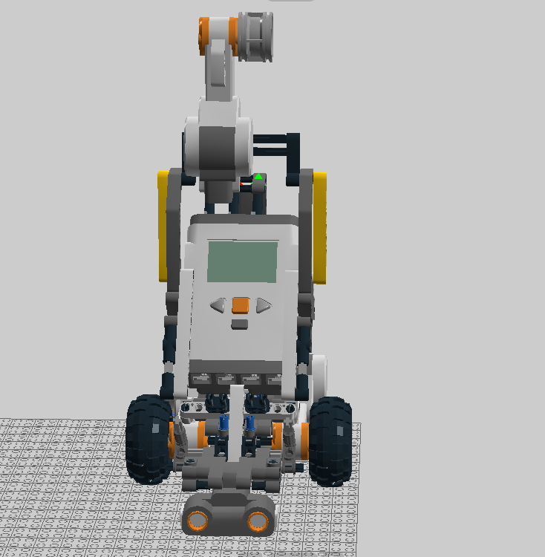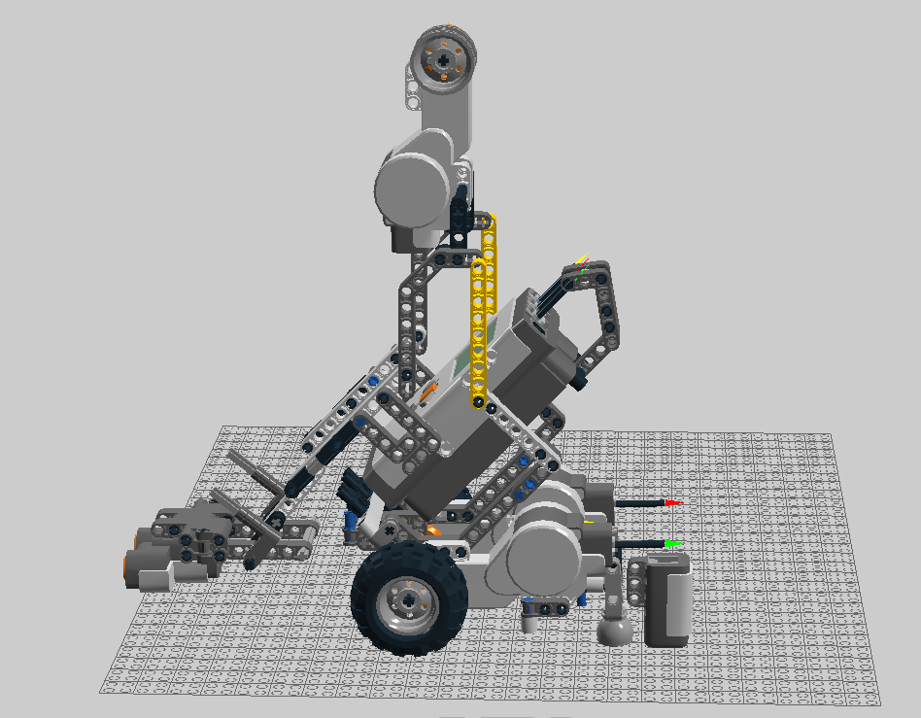

Left - *Figure 3.1.1: Alternative 1 Front View,* Right - *Figure 3.1.2: Alternative 1 Side View*

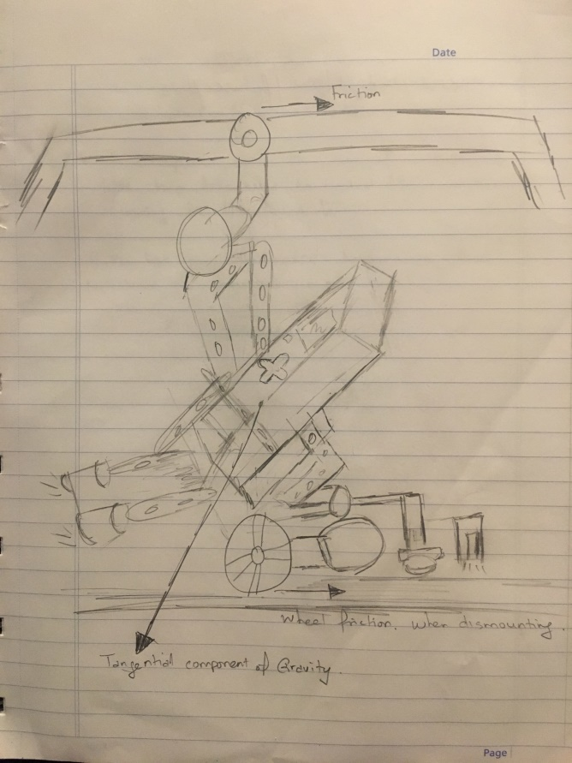

*Figure 3.1.3: Sketch of Alternative 1*

Alternative 1 Pros/Cons

|  |  |
| --- | --- |
| **Pros** | **Cons** |
| Lower mass 🡪 less power consumption | High center of gravity 🡪 increased chances of toppling |
| Small dimensions 🡪 smaller turning radius, easier to navigated through the shallow river crossing | Small base 🡪 higher chance of tilting |

**3.2 Alternative 2**

***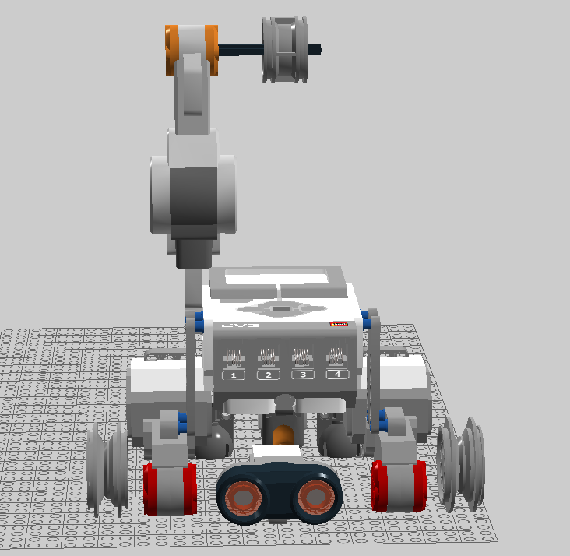*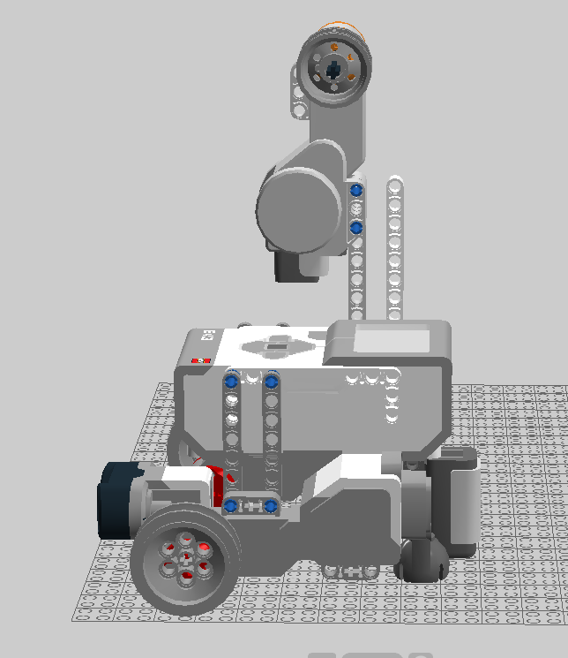**

Left - *Figure 3.2.1: Alternative 2 Front View,* Right - *Figure 3.2.2: Alternative 2 Side View*

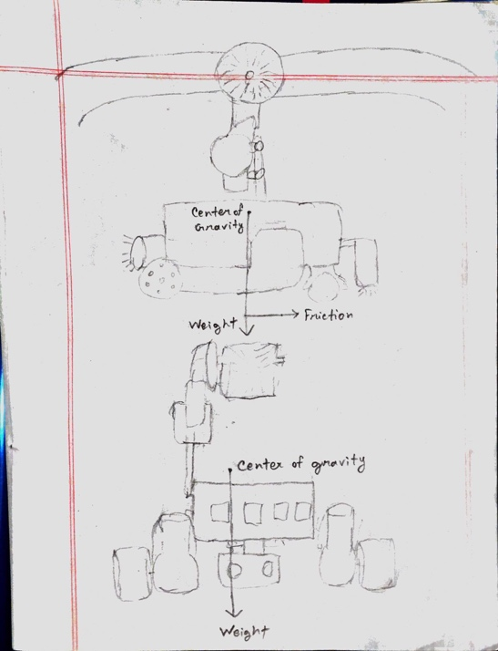

*Figure 3.2.3: Sketch of Alternative 2*

Alternative 2 Pros/Cons

|  |  |
| --- | --- |
| **Pros** | **Cons** |
| Wider base 🡪 better balance | Increased weight 🡪 more power consumption |
| Low center of gravity 🡪 less chances of toppling | Larger base dimensions 🡪 more difficult to navigate through the shallow river crossing |
| Center of gravity is shifted to the back due to motor placement 🡪 prevents from toppling forward after dismounting zip line |  |

**3.3 Alternative 3**

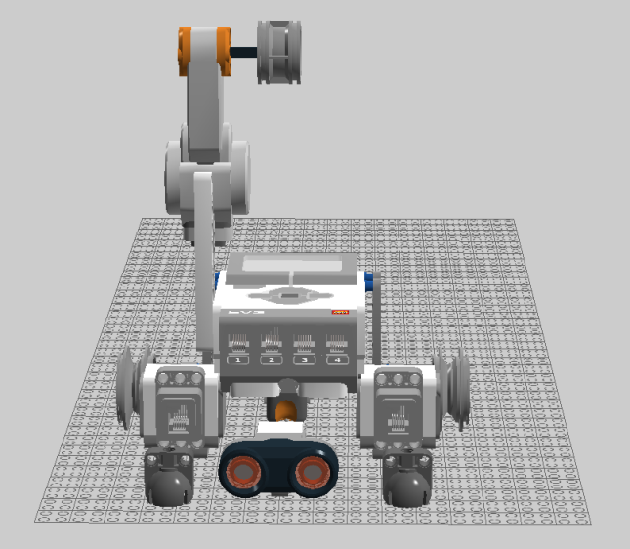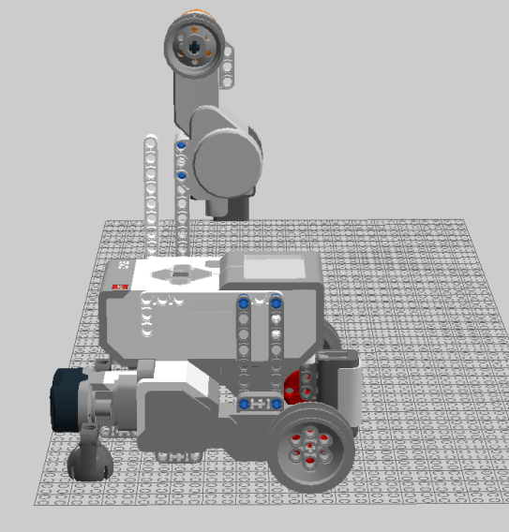

*Left - Figure 3.3.1: Alternative 3 Front View,* Right - *Figure 3.3.2: Alternative 3 Side View*

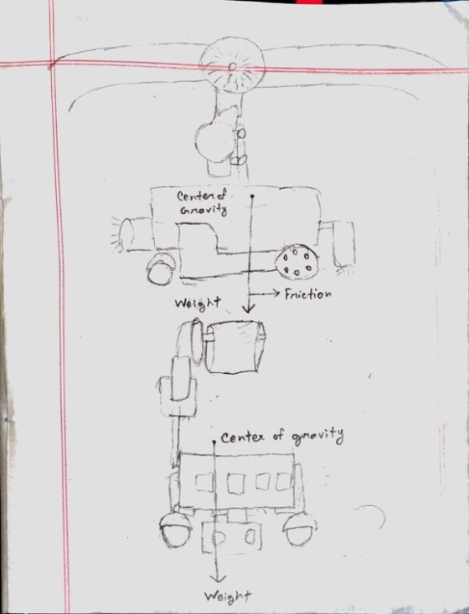

*Figure 3.3.3: Sketch of Alternative 3*

Alternative 3 Pros/Cons

|  |  |
| --- | --- |
| **Pros** | **Cons** |
| Wider base 🡪 better balance and weight distribution | Increased weight 🡪 more power consumption |
| Low center of gravity 🡪 less chances of toppling | Larger base dimensions 🡪 more difficult to navigate through the shallow river crossing |
|  | Center of gravity is shifted to the front due to the way the motors are placed 🡪 might topple due to sudden stops |

1. **Adopted Designs**

**4.1 Version 1.0**

**4.1.1 Visuals**

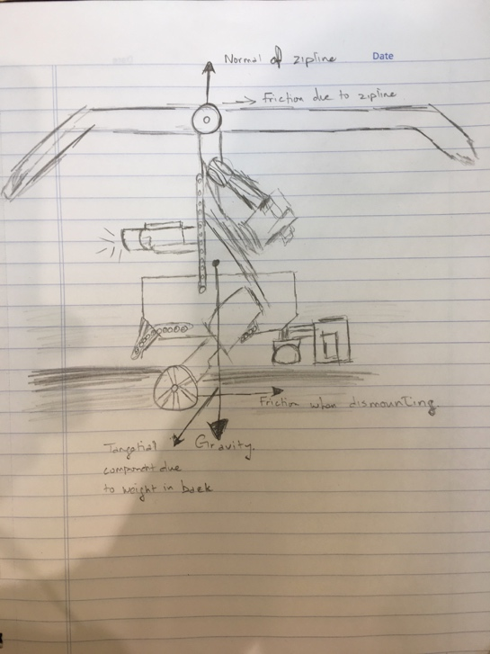

*Figure 4.1.1: Version 1.0 Sketch*

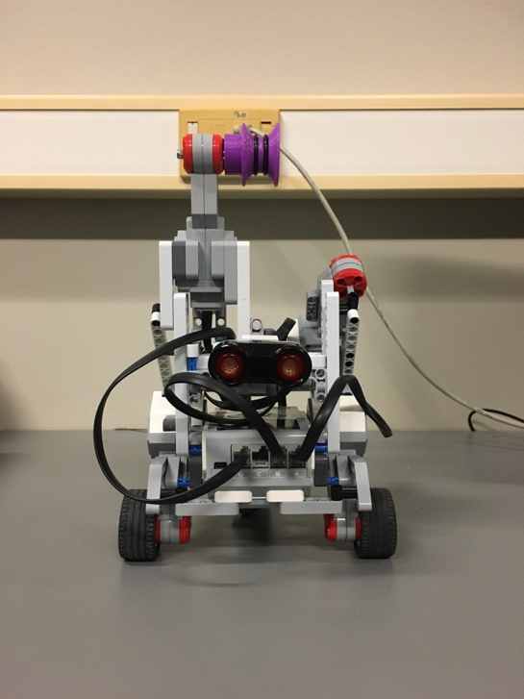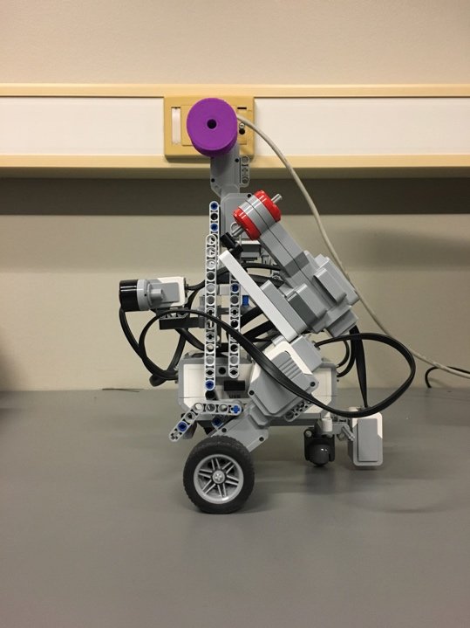

Left - *Figure 4.1.2: Version 1.0 Front View,* Right -*Figure 4.1.3: Version 1.0 Side View*

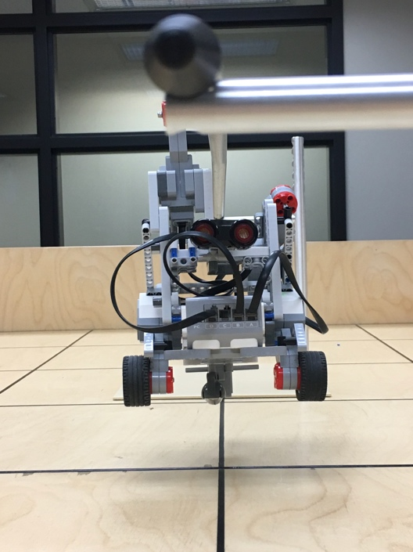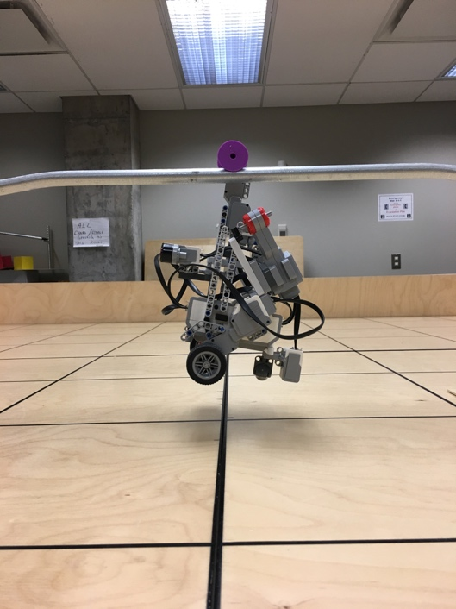

Left - *Figure 4.1.4: Version 1.0 on zip line,* Right - *Figure 4.1.5: Side view of Version 1.0 on zip line*

**4.1.2 Justification**

Comparing the figures in Section “4.1.1 Visuals” to the three alternative designs, it is shown that an amalgamation of Alternative 2 and Alternative 3 was chosen as the basis of the adopted design. The wheels were placed in the front of the robot rather than the back (see *Figure 4.1.3*) so that the brunt weight of the motors lies behind the wheels. The center of gravity and the forces acting on the robot are illustrated in *Figure 4.1.1*.This decision was made so that the design can dismount the zip line without tipping forwards.

The base of Alternative 3 was chosen due to the outcomes of the R&D labs. It was found that this base to wheel ratio was close to ideal for even balance and weight distribution. This is seen in *Figure 4.1.3*and *Figure 4.1.4*. As can be seen from *Figure 4.1.2* an extra motor was attached on the opposing side to the pulley attachment as a counterweight. This was done to further balance the weight of the design whilst traversing the zip line to minimize oscillations and ensure a controlled dismount.

**4.1.3 Features**

The features of Version 1.0 are as follows:

* even weight distribution and balance by addition of counterweight motor for smooth zip line traversal and controlled dismount
* a lower, centralized center of gravity to ensure stability
* compact design for shorter turning radius
* pulley attachment to allow for zip line traversal
* front-facing ultrasonic sensor to allow for ultrasonic localization
* downward-facing light sensor to allow for gridline detection and light localization

**4.1.4 Main Components**

* 1x EV3 Brick
* 4x EV3 Large Motors
* 2x Wheels
* 1x Ultrasonic Sensor
* 1x Light Sensor
* 1x Pulley
* 1x Metal Balancing Sphere

**4.2 Version 1.1**

**4.2.1 Visuals**



*Figure 4.2.1: Version 1.1 Sketch*

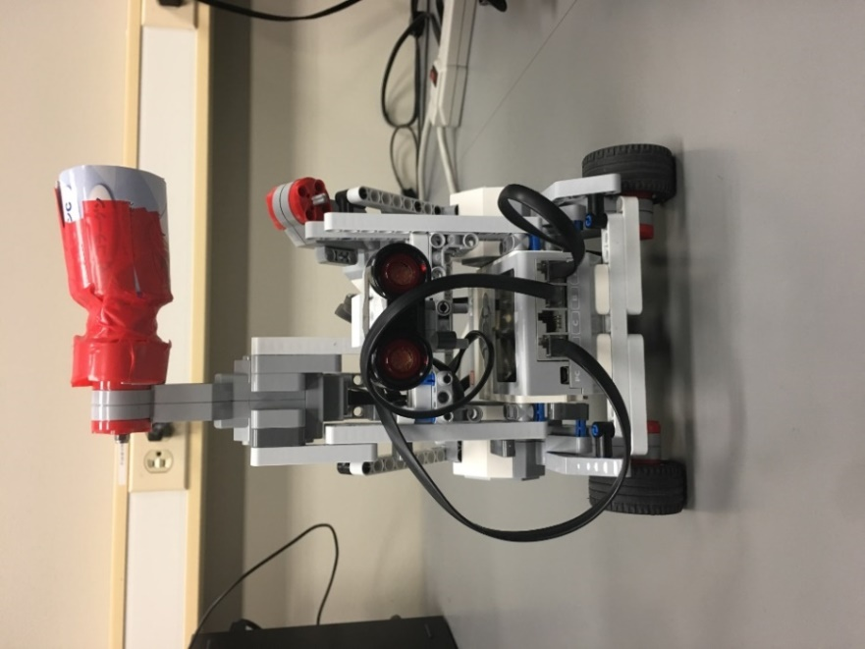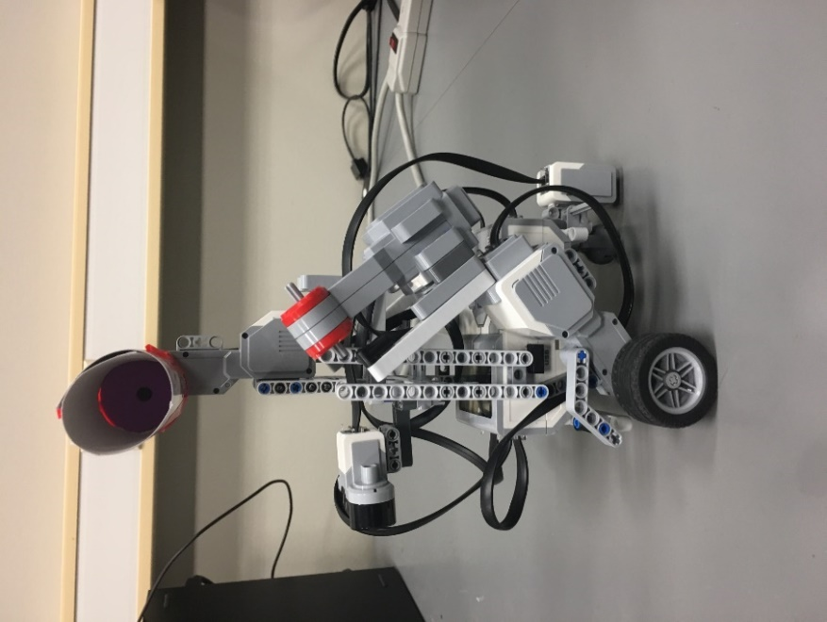

Left - *Figure 4.2.1: Version 1.1 Front View,* Right - *Figure 4.2.2: Version 1.1 Side View*

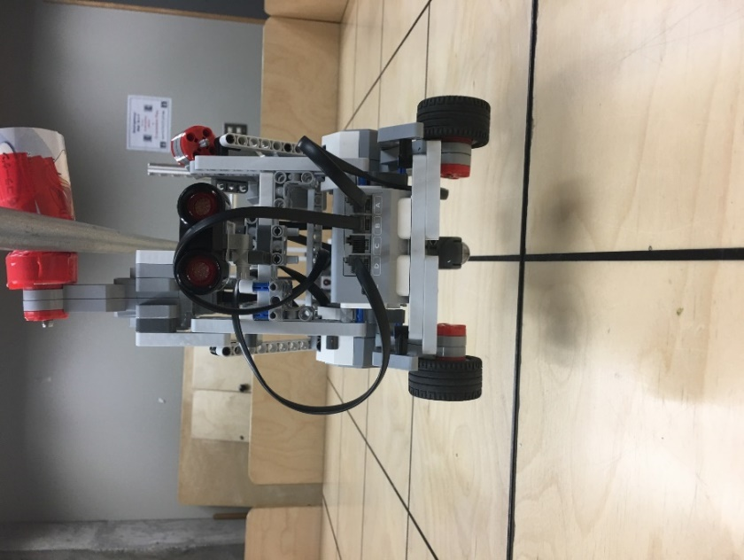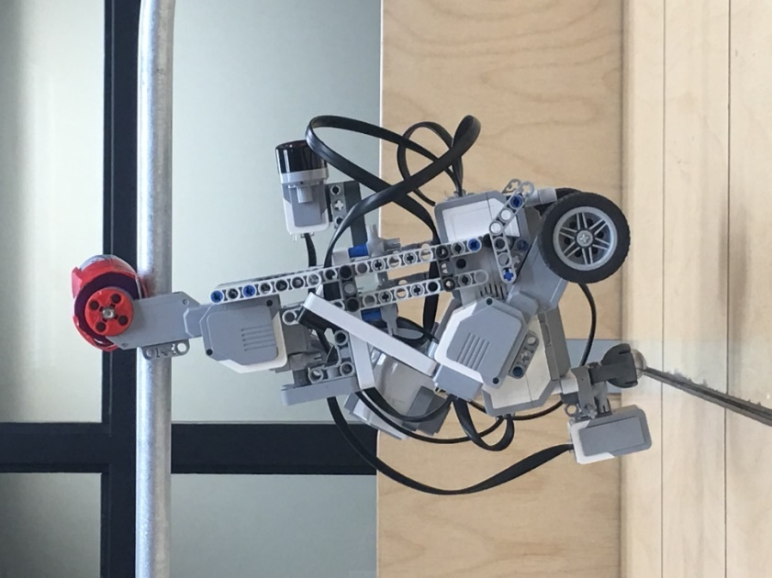

Left - *Figure 4.2.3: Version 1.1 on zip line*, Right - *Figure 4.2.4: Side view of Version 1.1 on zip line*

**4.2.2 Additions and Justification**

This version differs from the previous in only one aspect. A funnel-like device was added to the pulley. As no such device was included in the hardware kits provided, the funnel was constructed from cardboard and tape for quick and efficient installation. The materials used were easily accessible and easily allow for modifications.

Version 1.0 was only capable of fulfilling the hardware requirements for the project if the software developed was perfect and ran on the brick exactly as expected. However, the motors are not perfectly accurate and the sensors will detect noise. Specifically, Version 1.0 was capable of mounting and dismounting the zip line but only when the error in orientation was 2° away from the ideal. Therefore, to increase the margin of error and make the hardware more compatible with the software, the funnel-like device was added to extend the reach of the pulley. Referring to the results of “[5.1 Navigation Accuracy](Testing%20Document.docx#Navigation)” of the [*Testing Document*](Testing%20Document.docx), a funnel was required as the percentage of success in lining up with the zip line was marginal. In addition, “[4.1 Ultrasonic Localization Accuracy](Testing%20Document.docx#US_Localization)” and “[4.2 Light Localization Accuracy](Testing%20Document.docx#Light_Localization)” of the [*Testing Document*](Testing%20Document.docx) enforced the need for a funnel as the (X, Y) coordinates were perfect but the theta was sometimes off. The error in theta would result in failure of mounting the zip line. Thus, the funnel was a necessity to increase the success rate of mounting the zip line.

**4.2.3 Features**

The features of Version 1.1 are as follows:

* Includes all the features of Version 1.0 (See Section “*4.1.3 Features*”)
* Increased capability of mounting the zip line, even in the presence of minor errors in position and orientation

**4.2.4 Main Components**

* 1x EV3 Brick
* 4x EV3 Large Motors
* 2x Wheels
* 1x Ultrasonic Sensor
* 1x Light Sensor
* 1x Pulley
* 1x Metal Balancing Sphere
* 1x Funnel

**4.3 Version 1.2**

**4.3.1 Visuals**

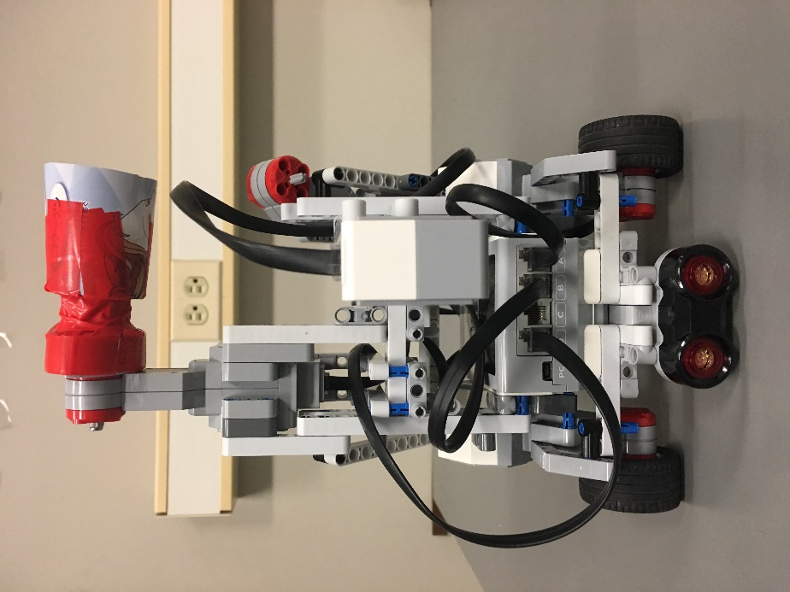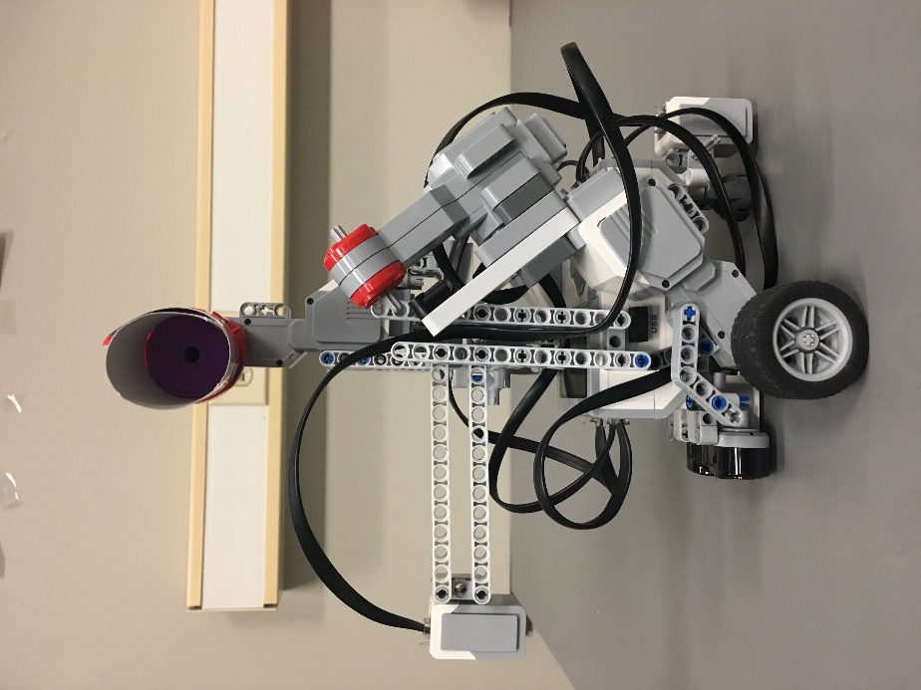

Left - *Figure 4.3.1: Version 1.2 Front View,* Right - *Figure 4.3.2: Version 1.2 Side View*

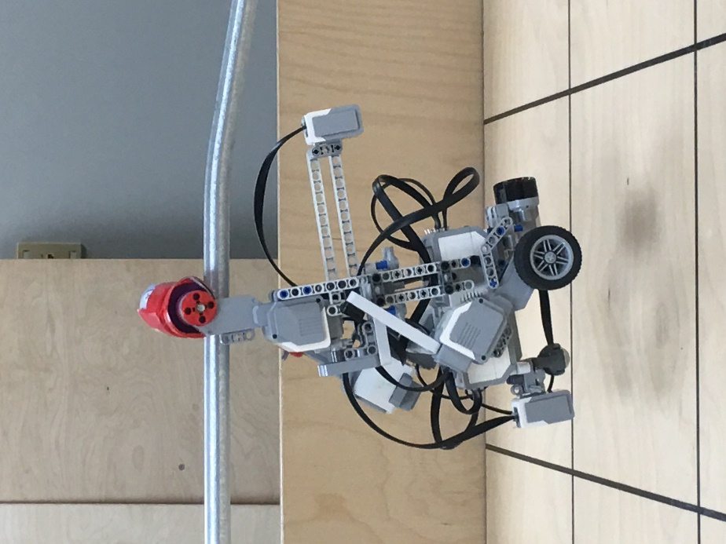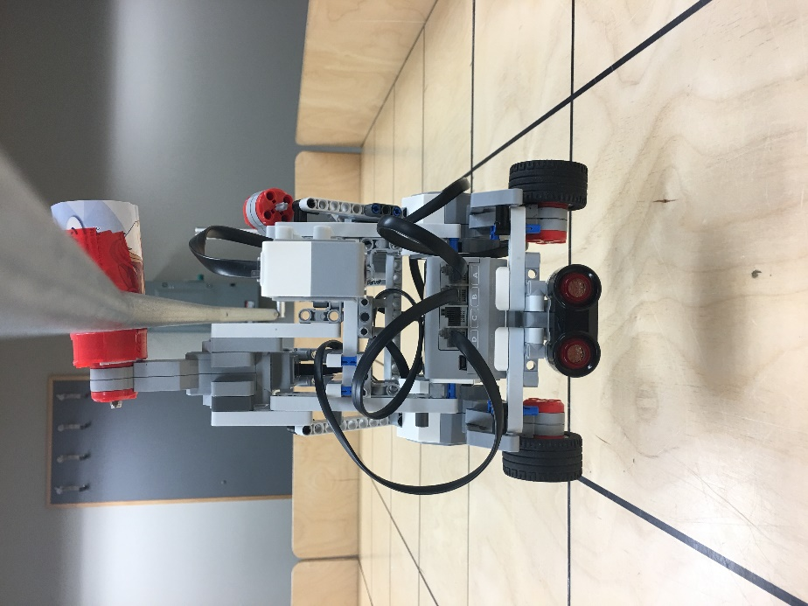

Left - *Figure 4.3.3: Version 1.2 on zip line*, Right - *Figure 4.3.4: Side view of Version 1.2 on zip line*

**4.3.2 Additions and Justification**

This version differs from the previous in only the placement and number of sensors. A light sensor was added facing downward in the front of the robot such that it was two Lego “notches” above the height of the flag as shown in *Figure 4.3.6*. This height specification was chosen by the Software Team so that the light sensor would always be a fixed distance from the flag. If the sensor was placed facing forward, the distance between the light sensor and the flag would be determined by the motors and the ultrasonic sensor. As the motors and ultrasonic sensors cannot provide the level of accuracy required, the light sensor would detect false positives and false negatives when searching for the flag since it determines the output based on the amount of light reflected.

After the light sensor was added to the design, there was another issue that arose. Referring to *Figure 4.3.5*and *Figure 4.3.6**,* the ultrasonic sensor was partially obstructed by the light sensor. In order to reduce interference, the ultrasonic sensor was relocated to a lower position shown in *Figure 4.3. 1**.* Also due to the outcome of the beta demo (see the [*Beta Demo Review Document*](../Main%20Documents/Beta%20Demo%20Review%20Document.docx)), the location of the ultrasonic sensor had to be lowered in order to ensure detection of all falling points when performing ultrasonic localization. Therefore, since flag detection and ultrasonic localization are both essential tasks in this project, these changes were necessary.

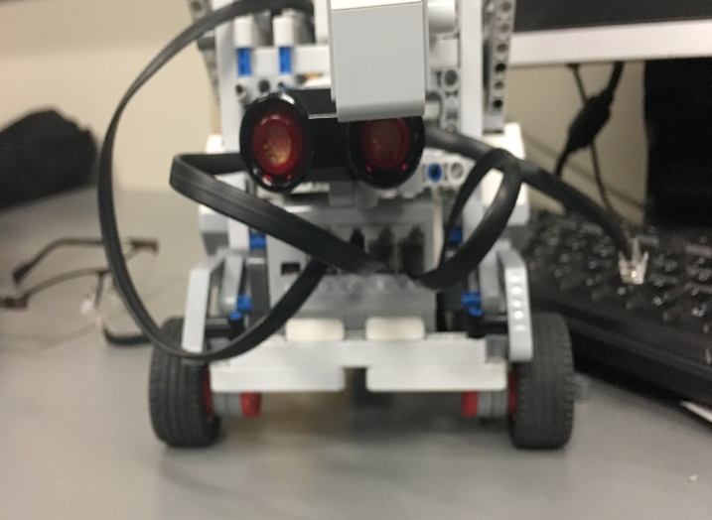 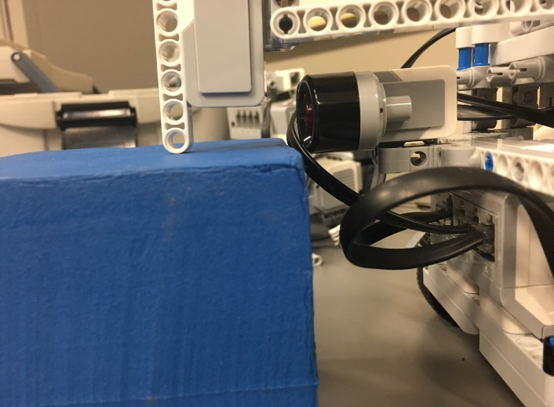

Left - *Figure 4.3.5: Version 1.1 with new light sensor added*, Right - *Figure 4.3.6: Side view of Version 1.1 with new light sensor added*

**4.3.3 Features**

The features of Version 1.2 are as follows:

* Includes all the features of Version 1.1 (See Section “*4.2.3 Features*”)
* Flag capture capability
* Increased falling point wall detection

**4.3.4 Main Components**

* 1x EV3 Brick
* 4x EV3 Large Motors
* 2x Wheels
* 1x Ultrasonic Sensor
* 2x Light Sensor
* 1x Pulley
* 1x Metal Balancing Sphere
* 1x Funnel

1. **Glossary of Terms**

* Falling point: the point at which the measured distance falls below a experimentally found constant (used in Ultrasonic Localization)
* R&D lab: the research and development labs that were conducted prior to starting the project